1.43: a) The magnitude of 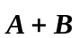 is
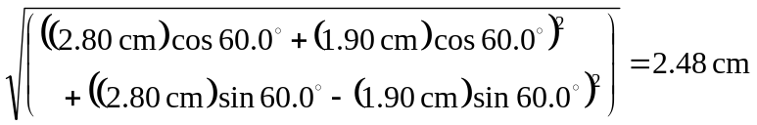
and the angle is
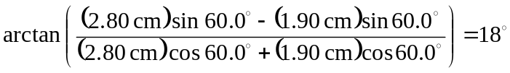
b) The magnitude of 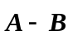is
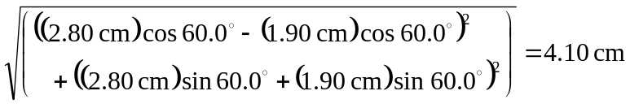
and the angle is
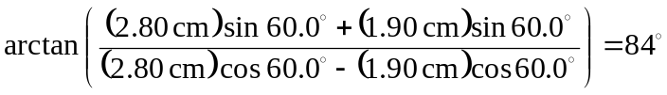
c)

